Name : ____________ Roll No: _______
PRACTICE ASSIGNMENT (2018-19)
Date: _________ CLASS – I
ENGLISH
Q1. Tick the naming words in the boxes given below:
- Pizza 3) Run
- Good 4) Delhi
Q2. Underline the describing words:
- A tall giraffe.
- This park is beautiful.
- Rohit is a strong boy.
Q3. Write the opposites of the given words:
- New - _____________ 4) Fat - _____________
- Sour - _____________ 5) Big - _____________
- Short -_____________ 6) Rich -_____________
Q4. Write ‘A’ or ‘An’ in the space provided:
- ______ aeroplane 3) ______ hen
- ______ mat 4) ______ owl
Q5. Look at the pictures and fill in the blanks with correct action words:
- The baby is C __ __ I N G.
- 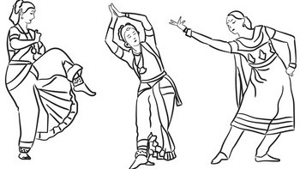 The girls are D __ __ __ I N G.

Q6. Give one word answer:
- Who helped Simi to pack her bag? ____________________
- Who brought noodles? ____________________
- What is the colour of Simi’s bag? ____________________
- Where does Flopy live? ____________________
Q7. Complete the following sentences:
- Aziz has pancakes with __________________.
- Vasu has muffins with __________________.
- Bosky is sad because he has no __________________ to chew.
- Bosky is happy because he has __________________ to play.
Q8. Answer the following questions:
- What do the children spread out?
Ans: _______________________________________________________
___________________________________________________________
- Where does the mother like to walk?
Ans: _______________________________________________________
____________________________________________________________
- Who takes Simi to the bus stop?
Ans: _______________________________________________________
____________________________________________________________

Q9. Write five lines on the topic ‘My Pet’.
My Pet
____________________________________________________________
____________________________________________________________
____________________________________________________________
____________________________________________________________
____________________________________________________________

