Name: ______________ PRACTICE ASSIGNMENT (2018-19) Roll no. ___
CLASS – III
Date: _______________ SOCIAL SCIENCE

SECTION A (OBJECTIVE)
Q1. Choose the correct option:
- Road transport includes _________.
- Ships ii) Metro trains iii) Aero planes iv) Cars
- People living in Kerala wear ___________ clothes.
- Woolen ii) Rayon iii)Cotton iv) Nylon
- ______________ is grown in Maharashtra.
- Orange ii) Grape iii) Banana iv) Apple
- ____________ is the most popular festival in Mumbai.
- Christmas ii) Pongal iii) Ganesh Chaturthi iv) Durga Puja
- At present, India has ___________ states.
- 26 ii) 29 iii) 28 iv) 27
- Which is the coldest planet in the Solar System?
- Mercury ii) Jupiter iii) Earth iv) Neptune
Q2. Fill in the blanks:
- People usually wear ____________ dresses on occasions such as birthdays.
- The food that people eat most often is known as their ____________
- Delhi is located on the banks of river______________.
- Lakshadweep island lies in _________________
- The layer of air surrounding the Earth is called the ______________.
Q3. Write ‘T’ for true and ‘F’ for false statements:
- People in Kolkata travel by Metro rail. ( )
- India is the sixth largest country in the world. ( )
- The Earth looks like a ‘green planet’ when we see it from the space. ( )
- Raj Ghat is the Samadhi of Jawaharlal Nehru. ( )

Q4. Match the following:
- Salwar suit ( ) Sweet
- Steamer ( ) Punjabi dress
- Turmeric ( ) Water transport
- Mysore Pak ( ) Spices
- Mekhla ( ) Road transport
- Bullock cart ( ) Assamese dress
Q5. Name them:
- Means of transport that moves on water._______________
- People who eat egg , fish or meat as a part of their diet _____________
- A road built on a raised structure _______________.

SECTION B (SUBJECTIVE)
Q6. Defines:
- Vehicle 2) Dhoti 3) Humid 4) Food grains
_________________________________________________________________________________________________________________________________________________________________________________________________________________________________________________________________________________________________________________________________________________________________________________________________________________________________________________________________________________________________________________________________________________________________________________________________________________________________________________________________________________________________________________________________________________________________
Q7. Correct the underline words and rewrite the sentences:
- The Earth is the second planet from the sun.
___________________________________________________________________

- Aeroplanes carry very heavy goods over large distances.
___________________________________________________________________

- Women in Bengal usually wear Ghagras.
___________________________________________________________________

Q8. Give three examples of each of the following:
- Water transport - _______________________________________________
- Oils used in cooking - ____________________________________________
- Clothes worn by Indian men - ______________________________________

Q9. Write the answers in one sentence:
- Name some common means of transport in villages.
Ans._____________________________________________________________
- Many food grains are eaten in our country. Name them.
Ans._____________________________________________________________
- What is a port?
Ans._____________________________________________________________
- What are Union territories?
Ans._____________________________________________________________
- What is the atmosphere made up of?
Ans._____________________________________________________________

Q10. Give reason: Our country is divided into many smaller areas called states.
_________________________________________________________________________________________________________________________________________________________________________________________________________

Q11. Differentiate between Road transport and Air transport.
Ans.___________________________________________________________________________________________________________________________________________________________________________________________________________________________________________________________________________________________________________________________________________

Q12. Write the answer of following questions in details:
- What are formal dresses? Give some examples.
Ans. _______________________________________________________________
___________________________________________________________________
___________________________________________________________________

- Why is rice grown in Bengal and Assam?
Ans. _______________________________________________________________
___________________________________________________________________
___________________________________________________________________

- Describe the different parts of India.
Ans. _______________________________________________________________
___________________________________________________________________
___________________________________________________________________
- Why do we need to save our planet? List two things that are provided to us by the Earth.
Ans. _______________________________________________________________
___________________________________________________________________
___________________________________________________________________
- What would happen if Earth was flat?
Ans. _______________________________________________________________
___________________________________________________________________
___________________________________________________________________

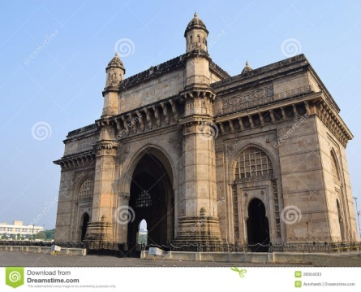
Q13. On the basis of the picture given below write the answers of the
following questions:
- Name the monument.
Ans._______________________________
- When and by whom it was built?
Ans. _______________________________________________________________
___________________________________________________________________

Q14. Locate the following on the political map of India:
- Capital of India
- Largest state in India
- Jammu & Kashmir
- One Union Territory

