**Name : ____________  Roll No: _______**

**PRACTICE ASSIGNMENT (2019-20)**

**Date: __________ CLASS – I**

**MATHEMATICS**

**Q1. Think and write the correct answer.**

1. Which day comes before Saturday?

Ans. __________________

1. If a burger cost Indian Rupee30 and chips costs Indian Rupee10, what is their total cost?

Ans.__________________

**Q2. Write ‘ T ‘ for true and ‘ F’ for false statements.**

1. 99 is the largest 2-digit number. ( )
2. The side showing value of the coin is called head. ( )

**Q3. Carry out subtraction by expansion.**

1. 7 6 = tens + Ones

- 5 3 = tens + Ones

Tens + Ones

**Q4. Fill in the blanks :-**

a) There are _____________ months in a year.

b) The long hand of the clock is the __________ hand.

c) The sum of 82 and 0 is ___________

**Q5. Complete the wheel.**

**6**

**5** **+20** **8**

**10**

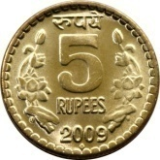**Indian Rupee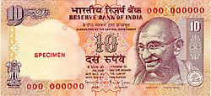Q6. Count how much money ?**

a)

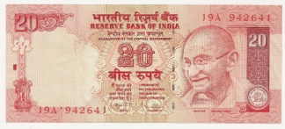

Indian Rupee b)

**Q7. Use repeated addition to find out how many in all:-**

_____ groups

 _____ in each group = _____ crayons in all

**Q8. There are 25 children in one bus. 32 children are in another bus.**

**How many children** **in both the buses?**

**Solution:** _____________________________________________

_____________________________________________

_____________________________________________

**Q9. Ram has 56 balloons. 45 of them are burst. How many balloons**

**are** **left with Ram**?

**Solution: _________________________________________________**

_________________________________________________

_________________________________________________